Experiment 3 – Introduction to SQL Server 2012 DBMS

Objective

- Familiarize students with SQL Server 2012 that is an RDMS by Microsoft
- Table creation, definition through script.
- Data import and export from files to DBMS (tables) using SQL import export utility.

SQL Server 2012 Installation:
SQL Server installation and configuration steps are given in the SQL server 2012 installation guide.ppt lying in the lab folder. This is to help the students in installing the server on their personal machines and get a know how of SQL architecture and its components.

Exercise 1: Creating relational database using SQL server management studio designer

Step 1: Open SQL server management studio

Start->Program Files ->SQL server 2012 -> SQL server management studio

Enter your server name as “172.16.209.177” username as “sa” password as “12345678”
Choose SQL server Authentication here as shown below

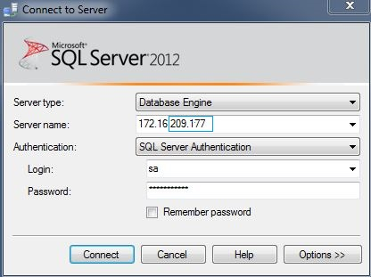
If you install SQL sever 2012 on your personal computer, then the details would be as under
Choose Windows Authentication here

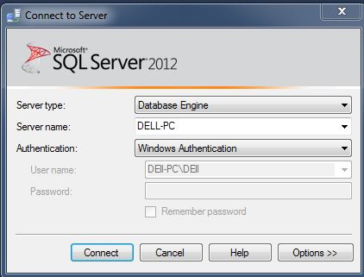

To add new Database Right click on Database folder and select New Database. Name this database as your roll number (beginning with letter L).
Eg: L15-5158

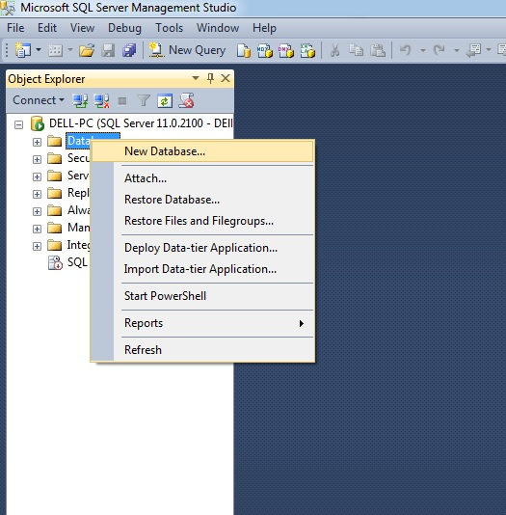

Step 2: Creating Tables through script in your database

The SQL DDL code given in the company.sql file (present in the lab folder) belongs to the following relational model:

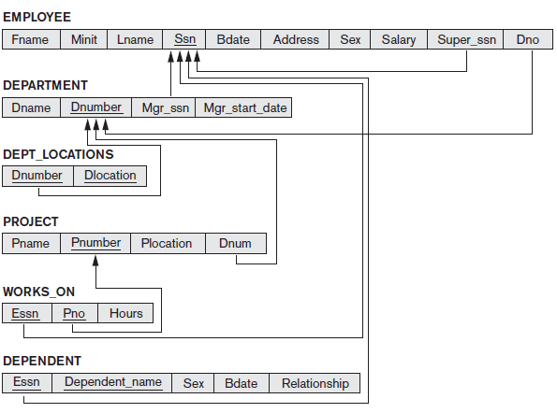

Please spend a few minutes going through the code in the company.sql file.

Now click on “New Query” after selecting your own database in the drop down
As shown in the image below

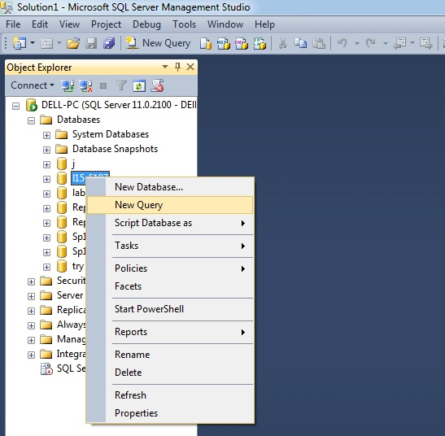
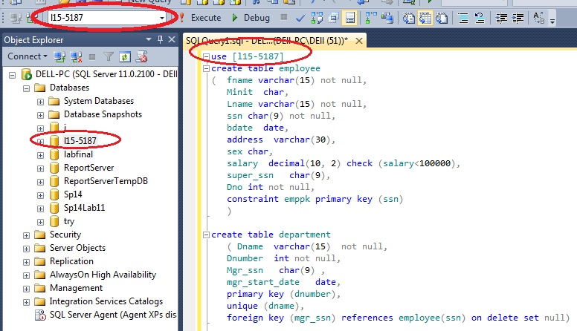

- In the SQL window that opens, copy the code from company.sql file and, paste it.
- Change use [your database] to the name of the database you created (your rollnumber).
- Highlight all code
- Now click on execute.
- If all goes well, you would see “command executed successfully” message and on expanding the tables folder in your database you would see the table that have just been created for you.

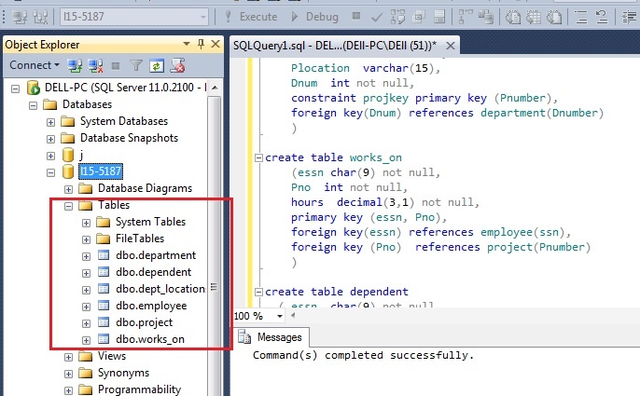

Exercise 2: Import data in to employee table using Import Export utility

Start->Program Files ->SQL server 2012 -> Import and Export data(64-bit)

- If you have a 32-bit operating system, then open import and export data (32-bit) and give company_data as your excel file source.

Select your Data source as Microsoft Excel (as data that you are going to import is present in the company.xls file. You have to repeat the following steps for all the tables that you created in Exercise1.

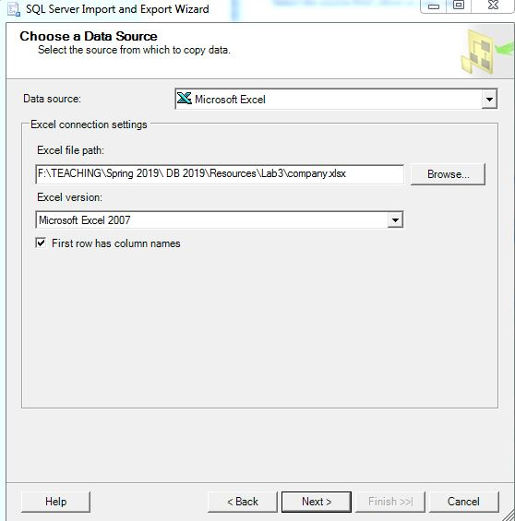

Don’t forget to check “Column names in the first data row”. Click on Next.

Select your destination table.

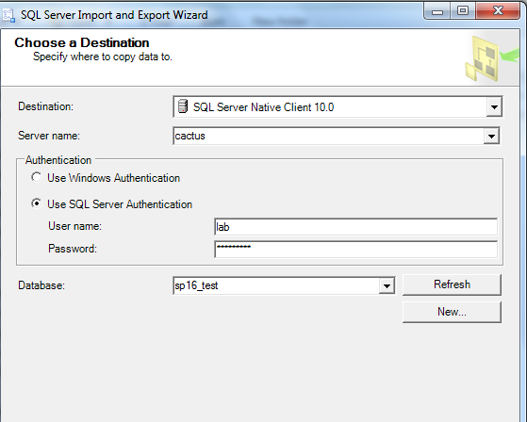

Click Next button .

Select the first option on next screen as given below
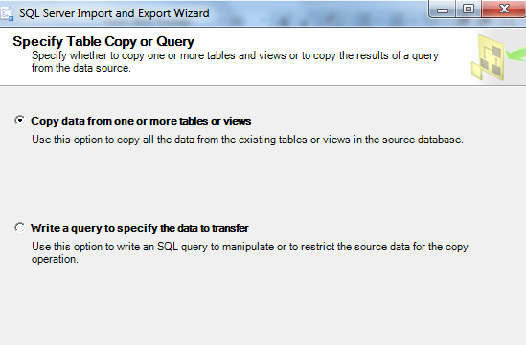

In the next screen that comes up, please make sure you have selected everything as given in the screen shot below. Choose destination without the $ sign ([dbo].[employee])

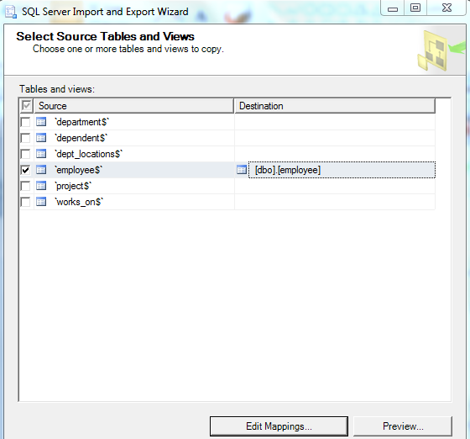

Now click on “Edit Mappings” button and on the next screen make sure that the destination columns are correctly selected.
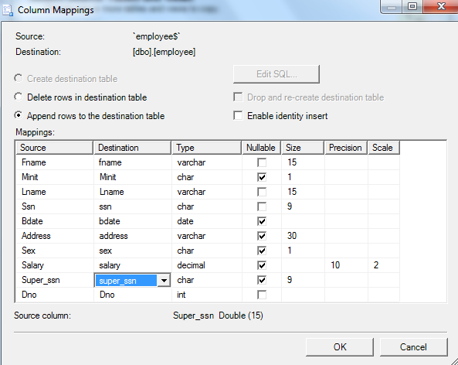

Click OK and then click Next to move to next screen till you get to the screen with “Finish” Button. In the screen that comes up you would see that 8 rows of data would have been transferred to the employee table, if everything went fine.
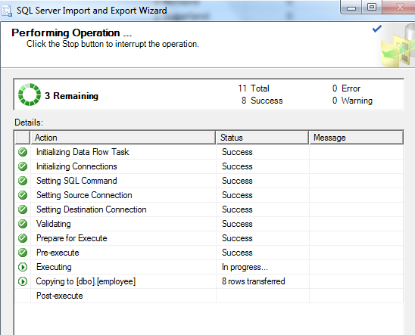

Selecting Data

Task 1: Selecting data from the table using selection Query
Start->Program Files ->SQL server 2012 -> Management studio
Select your database
Open Query window and type
Select * from employee
Execute Query.
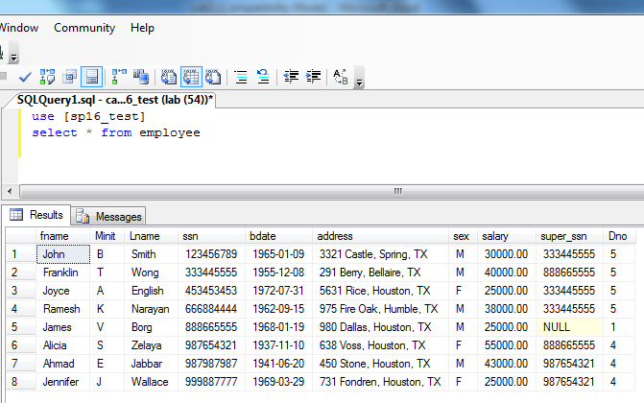

Exercise 3: Import data in to the other tables of company database using Import Export utility

Please repeat the steps in Exercise2 to import data into the rest of the tables. Please make sure that you follow the following order while importing the data

- Dependent table
- Department table
- Project table
- Dept_locations table
- Works_on table

Run the following script in SQL Server after having successfully imported data in all the tables to get your worked checked
use [your database]
select * from employee

select * from department

select * from dependent

select * from dept_locations

select * from project

select * from works_on

Post Lab:

- Write SQL script to create the database with the given relational data model given below:

Book
bookID | bookName | author

Author
authorID | authorName | authoraddress

- Import the given data in the table, you need to include screen shots of the data present in the tables after executing the select statement.

Book
bookID | bookName | author
1 | Chamber of Secrets | 101
2 | Alchemist | 102
3 | Philosopher’s stone | 101
4 | Heaven | 103
5 | Pride and Prejudice | 104

authorID | authorName | authoraddress
101 | J K Rowling | UK
102 | Paulo Coelho | Brazil
103 | Neil | US
104 | Jane Austen | US

